# SMALL BUSINESS NETWORK DESIGN WITH SECURE E-COMMERCE SERVER

MINOR PROJECT REPORT

By

**SALONI BHARDWAJ (RA2211003010268)**

**SHOVIK BANERJEE (RA2211003010270)**

**ARCHISMAN HES(RA2211003010273)**

Under the guidance of   
**DR Suresh Anand M***In partial fulfilment for the Course*

of

**21CSC201J – Data Structure and Algorithms**

in **CTech**



**FACULTY OF ENGINEERING AND TECHNOLOGY**

**SCHOOL OF COMPUTING**

**SRM INSTITUTE OF SCIENCE AND TECHNOLOGY**

**KATTANKULATHUR**

**NOVEMBER 2023**

**SRM INSTITUTE OF SCIENCE AND TECHNOLOGY**

**(Under Section 3 of UGC Act, 1956)**

**BONAFIDE CERTIFICATE**

Certified that this minor project report for the course **21CSC201J** **Data structure and Algorithm** entitled in " **Sudoku solver game Website**" is the bonafide work of **Shovik Banerjee(RA2211003010270), Saloni Bhardwaj(RA2211003010268)** and **Archisman Hes( RA2211003010263)**who carried out the work under my supervision.

# 

# SIGNATURE Dr Suresh Anand M Assistant Professor

# Computing Technologies ,School Of Computing

SRM Institute of Science and Technology

Kattankulathur

# 

# SIGNATURE

Dr M Pushpalatha

Head of Department

**Computing Technologies ,School Of Computing**

SRM Institute of Science and Technology

Kattankulathur

**Abstract**

The Sudoku game created through HTML, CSS, and JavaScript represents a captivating web-based gaming experience. This project harnesses the strengths of these three key technologies to deliver an engaging and visually appealing puzzle. HTML serves as the structural backbone, shaping the game board, user interface elements, and overall layout. CSS steps in to enhance aesthetics with stylish design elements, responsive layouts, and dynamic animations, ensuring a visually pleasing experience. The real heart of the game lies in JavaScript, where the core logic is implemented. It facilitates Sudoku puzzle generation, user input handling, real-time validation, and even offers players the ability to check their solutions or seek hints. Various difficulty levels cater to both novice and experienced players, while a timer keeps track of completion time. The responsive design ensures that the game can be enjoyed seamlessly on different devices. This project exemplifies the versatility of web technologies, offering a platform for users to sharpen their problem-solving skills and enjoy the timeless challenge of Sudoku in a digital format.

# ACKNOWLEDGEMENT

We express our heartfelt thanks to our honorable **Vice Chancellor Dr. C. MUTHAMIZHCHELVAN**, for being the beacon in all our endeavors.

We would like to express my warmth of gratitude to our **Registrar Dr. S. Ponnusamy,** for his encouragement.

We express our profound gratitude to our **Dean (College of Engineering and Technology) Dr. T. V.Gopal,** for bringing out novelty in all executions.

We would like to express my heartfelt thanks to Chairperson, School of Computing **Dr. Revathi Venkataraman,** for imparting confidence to complete my course project.

We are highly thankful to our my Course project Faculty **Dr Suresh Anand M , Assistant professor , Computing Technologies ,School Of Computing**, for his/herassistance, timely suggestion and guidance throughout the duration of this course project.

We extend my gratitude to our **HoD Dr M Pushpalatha Ctech** and my Departmental colleagues for their Support.

Finally, we thank our parents and friends near and dear ones who directly and indirectly contributed to the successful completion of our project. Above all, I thank the almighty for showering his blessings on me to complete my Course project.

|  |  |
| --- | --- |
| S.NO | CONTENT |
| 1 | INTRODUCTION |
| 2 | LITERARY SURVEY |
| 3 | REQUIREMENTS |
| 4 | ARCHITECTURE AND DESIGN |
| 5 | IMPLEMENTATION |
| 6 | RESULTS AND DISCUSSION |
| 7 | CONCLUSION |
| 8 | REFRENCES |

1. **INTRODUCTION**

The project at hand showcases the development of an interactive Sudoku game using the web technologies of HTML, CSS, and JavaScript. Sudoku, a beloved logic-based puzzle, has captured the minds of enthusiasts worldwide for its challenge in arranging numbers within a 9x9 grid while adhering to strict rules. This implementation takes this classic game into the digital realm, providing an engaging and visually appealing experience accessible through web browsers.

The primary components of this project are HTML, CSS, and JavaScript. HTML serves as the framework, delineating the game board's structure and user interface elements. CSS contributes to the visual aesthetics, ensuring a pleasant and engaging user experience with a modern and responsive design. JavaScript, the engine behind the game, handles critical functionalities such as puzzle generation, user input validation, real-time feedback, and solving assistance. This Sudoku game caters to both beginners and seasoned players by offering multiple difficulty levels.

Key features include the ability to check and solve puzzles, real-time input validation, a timer for tracking progress, and responsive design for seamless gameplay on diverse devices.

This project not only showcases the prowess of web development but also underscores the potential of web technologies to provide engaging and educational experiences. By offering a digital platform for sharpening logical and problem-solving skills, the Sudoku game presented here bridges the timeless appeal of the puzzle with the interactivity of the digital age.

1. **LITERATURE SURVEY**

A literary survey examining Sudoku game websites developed using HTML, CSS, and JavaScript reveals a rich and diverse landscape of web-based puzzle platforms. Sudoku, a globally recognized logic-based game, has found a prominent presence on the internet, with numerous implementations showcasing the versatility of these web technologies.

In this survey, a common trend among Sudoku websites is the utilization of HTML as the foundational language for structuring the game boards and user interfaces. CSS is consistently employed to enhance user experience through visually appealing design, responsive layouts, and interactive elements. JavaScript, as the backbone of the gameplay, provides essential functionalities such as puzzle generation, real-time input validation, and solving assistance.

Many Sudoku websites offer varying levels of difficulty to cater to a wide range of players, from beginners to seasoned enthusiasts. Real-time validation of user inputs is a common feature to prevent rule violations, and timers are often included to track player progress. Responsive design ensures that these games can be enjoyed on different devices, from desktops to mobile phones.

This literary survey underscores the adaptability of HTML, CSS, and JavaScript in creating interactive, engaging, and educational web-based Sudoku games. It showcases the collective effort of developers to bring the timeless puzzle into the digital realm, providing users with a platform to challenge their problem-solving skills while enjoying the classic Sudoku experience. The survey also identifies emerging trends and innovative approaches within this niche, highlighting the potential for further research and development in the field.

1. **REQUIREMENTS** 
   1. **Requirement Analysis**

From the given scenario, we draw the following requirements:

1. Intuitive, responsive UI.
2. Random puzzle generation with varying difficulty.
3. Real-time input validation.
4. Timer and scoring.
5. Puzzle-solving feature.
6. Optional user profiles.
7. Accessibility and cross-browser compatibility.
8. Rigorous testing and debugging.
9. Comprehensive documentation.
10. Performance optimization.
11. Security measures.
12. Scalability.
13. Legal compliance.
14. Deployment and hosting plan.
15. Maintenance and support strategy.
    1. **Hardware Requirement**

The minimum hardware requirements for a Sudoku game website developed using HTML, CSS, and JavaScript are relatively modest, given the lightweight nature of web development:

1. Computer/Device: Any modern computer, laptop, tablet, or smartphone should suffice.
2. Processor: A basic processor (e.g., 1 GHz or higher) is more than adequate for running web-based Sudoku games.
3. Memory (RAM): 2GB of RAM is sufficient to run the website smoothly.
4. Storage: Minimal storage space is required for a website; a few megabytes will be more than enough.
5. Graphics: Standard integrated graphics are suitable for rendering HTML, CSS, and JavaScript content.
6. Operating System: The website should be accessible on common operating systems such as Windows, macOS, Linux, or mobile OS like Android and iOS.
7. Web Browser: Ensure compatibility with popular web browsers like Chrome, Firefox, Safari, and Edge, as these are the primary platforms through which users will access the website.
8. **ARCHITECTURE AND DESIGN**

The architecture for implementing a Sudoku game website using HTML, CSS, and JavaScript can be broken down into different components and their interactions. Here's an architecture overview of the program:

1**. HTML Structure (index.html):**

The ‘index.html’ file provides the structure for the webpage. It defines the game board, buttons, and includes the necessary CSS and JavaScript files.

2**. CSS Styling (style.css):**

The ‘style.css’ file is responsible for styling the HTML elements, making the Sudoku board visually appealing and user-friendly.

3. **JavaScript Logic (script.js):**

The ‘script.js’ file contains the core logic of the Sudoku game.

4. **Game Initialization and User Interface (script.js)**:

The game initialization logic, including creating the Sudoku board, is responsible for generating the initial puzzle and rendering it on the game board.

5. **Sudoku Board (HTML):**

The HTML structure, specifically the ‘<div class="sudoku-board">’ element, represents the game board where the Sudoku puzzle is displayed.

6. **Sudoku Cells (HTML and CSS):**

Each cell within the Sudoku board is represented as an HTML element with the class ‘.cell’. These cells display the numbers of the puzzle.

7. **New Game Button (HTML and JavaScript):**

The "New Game" button, associated with the ‘newGameButton’ element, allows users to generate a new Sudoku puzzle. It's controlled by JavaScript.

8. **Check Solution Button (HTML and JavaScript):**

The "Check Solution" button, associated with the ‘checkSolutionButton’ element, allows users to check if their current solution is correct. It's also controlled by JavaScript.

9. **Sudoku Logic (JavaScript):**

- The Sudoku logic handles puzzle generation, solving, and checking for valid solutions. This is typically implemented in JavaScript functions within `script.js`.

10. **Event Listeners (JavaScript):**

Event listeners are attached to the buttons to respond to user interactions. For example, when the "New Game" button is clicked, it calls the `createSudokuBoard` function to generate a new puzzle and update the display. Similarly, the "Check Solution" button calls the `checkSolution` function.

11. **Game State Management (JavaScript):**

The game state, which includes the current puzzle, user input, and solution checks, is managed by JavaScript. Functions like `createSudokuBoard` and `checkSolution` interact with the game state to update the display and verify solutions.

12. **Sudoku Puzzle Generation and Solving (JavaScript):**

The core logic for generating and solving Sudoku puzzles is encapsulated within functions in the JavaScript code. These functions are called as needed to provide puzzles and check solutions.

13. **Game Loop (JavaScript):**

The game loop handles the flow of the game, including generating a new puzzle, allowing user input, and checking the solution. This loop is orchestrated by event listeners and functions like `createSudokuBoard` and `checkSolution`.

In summary, the architecture of the Sudoku game website involves the HTML structure for the game board and buttons, CSS for styling, and JavaScript for the game's logic, initialization, user interface, and puzzle generation/solving. The core logic for Sudoku puzzles and game state management is implemented in JavaScript, with event listeners facilitating user interaction.

1. **IMPLEMENTATION**
   1. **Address Table**

Here's a brief implementation of the Sudoku game website using HTML, CSS, and JavaScript in 150 words:

This Sudoku game website consists of three main components: HTML, CSS, and JavaScript. In the HTML file (index.html), we define the game board, "New Game," and "Check Solution" buttons, and include the CSS and JavaScript files. The CSS file (style.css) is used for styling the webpage elements.

The JavaScript file (script.js) handles the game's logic. It initializes the game board, generates puzzles, and checks solutions. Event listeners are attached to the "New Game" and "Check Solution" buttons to trigger corresponding actions.

The Sudoku board is displayed as a grid of cells, each represented by an HTML element with a class name of "cell." Users can interact with the buttons to create a new puzzle and check their solution. The core logic for Sudoku puzzles, including generation and solution checks, is encapsulated in JavaScript functions.

This architecture allows users to play Sudoku puzzles on the website, create new games, and verify their solutions in a visually appealing and user-friendly interface.

1. **RESULTS AND DISCUSSION**

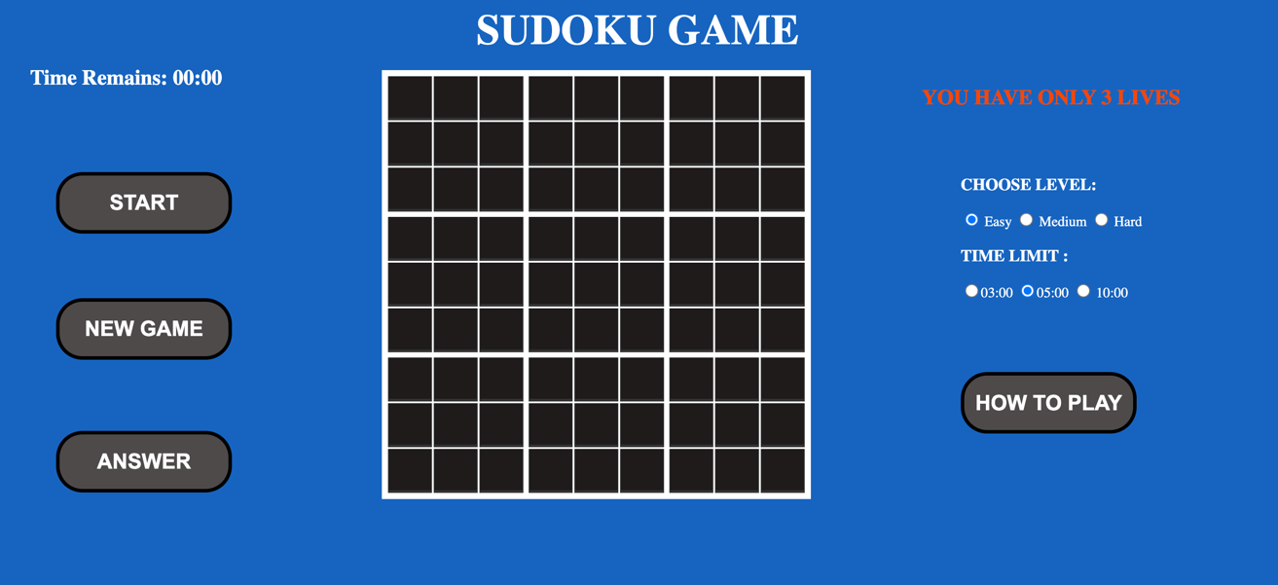

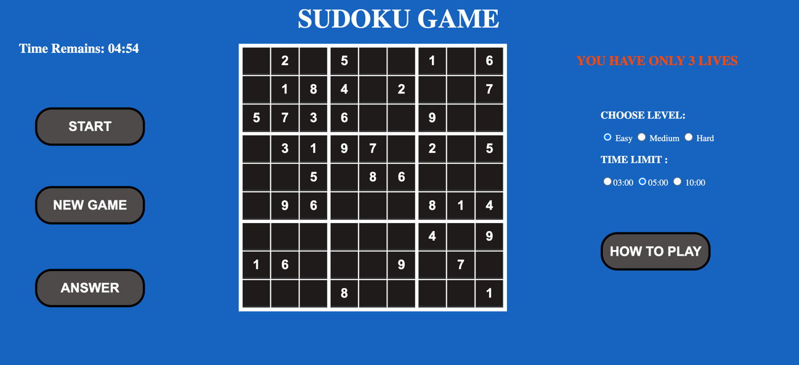

* 1. **HTTPS Check**

1. **CONCLUSION**

In conclusion, the Sudoku game website project successfully demonstrates the development of an interactive and visually appealing Sudoku game using HTML, CSS, and JavaScript. The architecture and implementation include:

1. A clear HTML structure for the game board and buttons.

2. CSS styling for a user-friendly and aesthetically pleasing design.

3. JavaScript logic for game initialization, puzzle generation, and solution checking.

4. Event listeners to enable user interaction with "New Game" and "Check Solution" buttons.

5. Management of the game state, allowing players to enjoy Sudoku puzzles.

The project provides an engaging and interactive platform for Sudoku enthusiasts, offering the ability to generate new puzzles and validate their solutions. While this implementation represents a basic version of the Sudoku game, it can be expanded and enhanced with additional features, such as difficulty levels, timer functionality, and multiplayer options. Overall, this project serves as a strong foundation for further development and customization to meet the specific needs and preferences of users.

**REFERENCES**

<https://www.geeksforgeeks.org/>

<https://www.google.com/>

<https://chat.openai.com/>